Name | Vineet Parmar
UID no. | 2021300092
Experiment No. | 9

AIM: | Demonstrate the use of pointers to solve a given problem.
Program 1
PROBLEM STATEMENT : | Write a program to swap smallest and largest element in an array using pointers
ALGORITHM: | - START  - Define void function swap with a integer n and integer array arr[n] as parameter  - I=0, min_index=0, max_index = 0  - Loop from i=0 to n-1  A. If *(arr+i) < *(arr+min index)  min index = i  B. If *(arr + i) > *(arr + max_index)  max_index = i  - Temp = *(arr + max_index)  - *(arr + max_index) = *(arr + min_index)  - *(arr + min_index) = temp  - Define main function  - Input number of elements n  - Input array arr[n]  - Call function swap(n, arr)  - Print array arr[n]  - STOP
PROGRAM: | #include<stdio.h>  void swap(int n, int arr[n])  {  int i,min_index = 0, max_index = 0;  for(i=1;i<n;i++)  {  if(*(arr+i)<*(arr+min_index))  min_index=i;  if(*(arr+i)>*(arr+max_index))  max_index=i;  }  int temp = *(arr + max_index);  *(arr + max_index) = *(arr + min_index);  *(arr + min_index) = temp;  }  int main()  {  int n;  printf("Enter number of elements of array: ");  scanf("%d",&n);  printf("Enter elements of the array: ");  int arr[n];  for(int i=0;i<n;i++)  scanf("%d",(arr+i));  swap(n,arr);  printf("The array after swapping Maximum and Minimum elements is:\n");  for(int i=0;i<n;i++)  printf("%d ",*(arr+i));  return 0;  }
RESULT: 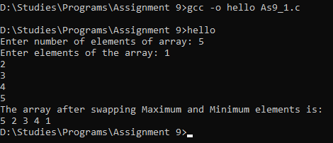
Program 2
PROBLEM STATEMENT : | Write a program to reverse the position of all elements in the array using pointers.
ALGORITHM: | - START  - Define void function reverse with integer n and integer array arr[n] as parameters.  - Loop from I = 0 to n/2-1  A. temp = *(arr + i)  B. *(arr + i) = *(arr + n-1 –i)  C. *(arr + n-1 – i) = temp  - Define main function  - Input no of elements of array n  - Input array arr[n]  - Call function reverse(n, arr)  - Print arr[n]  - STOP
PROGRAM: | #include<stdio.h>  void reverse(int n, int arr[n])  {  for(int i=0;i<n/2;i++)  {  int temp = *(arr + i);  *(arr + i) = *(arr + n-1 - i);  *(arr + n-1 - i) = temp;  }  }  int main()  {  int n;  printf("Enter number of elements of array: ");  scanf("%d",&n);  printf("Enter elements of the array: ");  int arr[n];  for(int i=0;i<n;i++)  scanf("%d",(arr+i));  reverse(n,arr);  printf("The array after reversing is:\n");  for(int i=0;i<n;i++)  printf("%d ",*(arr+i));  return 0;  }
RESULT: 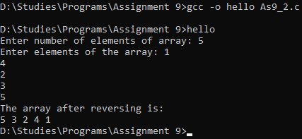
Program 3
PROBLEM STATEMENT: | Write a program to perfor m matrix multiplication using pointers. Dimensions of matrices will be decided by the user.
ALGORITHM: | - START  - Define void function multiply with 4 integers m, n, a, b and three 2-D integer arrays arr1[m][n], arr2[a][b], arr3[m][b]  - If n is equal to a  A. Loop from I = 0 to m-1  I. Loop from J = 0 to b-1  a. sum = 0  b. Loop from k = 1 to n-1  sum += (*(*(arr1 + i) + k)) * (*(*(arr2 + k) + j))  - Define main function  - Input dimensions of first matrix m and n  - Input first matrix arr1[m][n]  - Input dimensions of second matrix a and b  - Input second matrix arr2[a][b]  - Define arr3[m][b]  - Call function multiply(m, n, a, b, arr1, arr2, arr3)  - Print 2-D array arr3  - STOP
PROGRAM: | #include<stdio.h>  void multiply(int m,int n ,int arr1[m][n],int a, int b, int arr2[a][b],int arr3[m][b])  {  if(n==a)  for(int i=0;i<m;i++)  for(int j=0;j<b;j++)  {  int sum = 0;  for(int k=0;k<n;k++)  sum += (*(*(arr1 + i) + k)) * (*(*(arr2 + k) + j));  *(*(arr3 + i) + j) = sum;  }  }  int main()  {  int m,n,a,b;  printf("Enter dimensions of matrix ");  scanf("%d %d",&m,&n);  printf("Enter elements of the array: ");  int arr1[m][n];  for(int i=0;i<m;i++)  for(int j=0;j<n;j++)  scanf("%d",(*(arr1 + i) + j));  printf("Enter dimensions of matrix ");  scanf("%d %d",&a,&b);  printf("Enter elements of the array: ");  int arr2[a][b];  for(int i=0;i<a;i++)  for(int j=0;j<b;j++)  scanf("%d",(*(arr2 + i) + j));  int arr3[m][b];  multiply(m,n,arr1,a,b,arr2,arr3);  printf("The matrix after multiplying is:\n");  for(int i=0;i<m;i++)  for(int j=0;j<b;j++)  printf("%d ", *(*(arr3 + i) + j));  return 0;  }
RESULT: 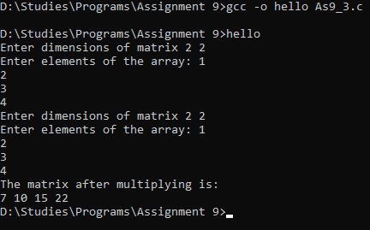
CONCLUSION: | In this experiment, we learned how to take inputs, print outputs of 1D arrays and how to perfom operations on them using pointers.

